PRACTICAL 12
Aim: : Using XSL display student information in tabular format

Stud.xsl
<?xml version="1.0" encoding="UTF-8"?>
<xsl:stylesheet version="1.0"
xmlns:xsl="http://www.w3.org/1999/XSL/Transform">
<xsl:template match="/">
<html>
<body>
<h2>Students Result:</h2>
<table border="1">
<tr bgcolor="cyan">
<th>Roll-No</th>
<th>Name</th>
<th>Marks</th>
</tr>
<xsl:for-each select="students/student">
<tr>
<td><xsl:value-of select="rollno"/></td>
<td><xsl:value-of select="name"/></td>
<td><xsl:value-of select="marks"/></td>
</tr>
</xsl:for-each>
</table>
</body>
</html>
</xsl:template>
</xsl:stylesheet>

Student.xml
<?xml version="1.0" encoding="UTF-8"?>
<?xml-stylesheet type="text/xsl" href="stud.xsl"?>
<students>
<student>
<rollno>37</rollno>
<name>Abc</name>
<marks>78</marks>
</student>
<student>
<rollno>36</rollno>
<name>Xyz</name>
<marks>78</marks>
</student>
</students>

OUTPUT:

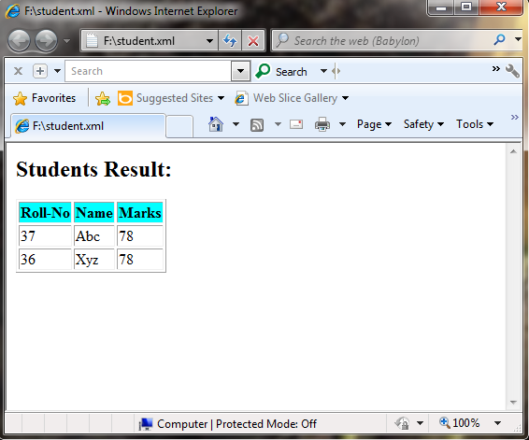

OUTPUT:
